Supplement 11

Outsourcing as a Supply-Chain Strategy

**Background**

Outsourcing is a growing trend in business with many success stories and many failures. It can be an emotional subject for some, so instructors need to be sensitive to potential student concerns and opinions about the subject. At the same time, the existence of strong opinions within the classroom can produce some lively class discussions. Instructors should try to present a balanced view of outsourcing, including the advantage, the risks and disadvantages, and the potential ethical dilemmas.

**Class Discussion Ideas**

1. Most students will have an emotional opinion of U.S. firms’ outsourcing and offshoring practices. Have students identify firms that have outsourced and explain possible reasons for the decision.

2. There is an excellent fictional mini-case published in *Harvard Business Review* (vol. 71, no. 1, Jan./Feb. 1993, pp. 12-23) called, “Third-World Families at Work: Child Labor or Child Care?” A U.S. manufacturer has a global policy of absolutely no subcontracting with factories that utilize underage workers. While the policy seems straightforward and clear to the U.S. manager, he sees a different side of the story when he visits Pakistan. Throwing the young girls out onto the street does not necessarily seem like such a good and clear-cut solution once the manager visits the plant. But what if *60 Minutes* catches wind of the situation? The case is short enough that students could read it quickly prior to or at the beginning of class. The case is still very relevant today, and it can produce a good 20-30 minute passionate class discussion. Six experts chimed in with their opinions, and these can be shown to the students for comparison once the class discussion has concluded.

Instructors might also refer to the Ethical Dilemma on page 52 of Chapter 1. This is a handy and very brief case written in the same spirit as the *HBR* article. Students could all read the Ethical Dilemma and then discuss.

3. Some students may feel that outsourcing simply should not occur because it is unethical to lay off productive and loyal workers just to save some money. Instructors could explore varying student opinions about this issue and even ask the question, “What if it was your job (or your parent’s job) being outsourced?”

**Active Classroom Learning Exercises**

1. Have students split into small groups, and have each group identify non-U.S. firms that have located their factories in the U.S. and indicate possible reasons for the decision. Let each group share its findings with the class.

2. Play the *Outsourcing Game* found at http://www.emeraldwise.com/og.html

* + The Scenario: Acme is a well-known company that sells its widgets through retailers across the United States. Acme currently offers two widget products, a high-end version, and a low-end version. Game participants are divided into five teams to play the roles of Acme, BuildIT (contract manufacturer), Design (outsourced design firm), Hi-N (supplier of high-end subassembly), and Loen (supplier of low-end subassembly).
  + The Decision: Acme is interested in using a common subassembly for its widget product line. However, because of outsourcing, Acme must work with its supply chain partners to implement the decision. Participants, through a series of negotiations, determine how the scenario plays out.

**Company Video**

1. *Outsourcing Offshore at Darden (10:56)*

Darden Restaurants imports millions of pounds of seafood annually. The firm achieves this via a complex outsourced network of vendors extending to 40 countries. Darden strives to “source the best suppliers globally” by examining import data and even using its existing network of vendors for referrals. After interest is established, Darden conducts a plant visit to determine the quality of the facilities. If the supplier becomes part of the network, Darden trains the supplier on how to comply with Darden’s “cold chain” requirements, including the use of proper containers, gel packs, and temperature monitors. Darden seeks durable long-term relationships with suppliers, not necessarily choosing based on lowest cost. Darden’s standards are higher than most U.S. government standards, and it rejects certain shipments that the government would not based on things like poor color and misshaped product, or anything that might suggest that something in the integrity of the cold chain might have been compromised. Why does Darden outsource its seafood? A primary reason is that many countries will not even grant fishing licenses to non-native fishermen. Furthermore, Darden is not in the seafood production business—it’s in the restaurant business. But due to its massive scale, Darden can work directly with suppliers instead of middlemen, allowing the company to remove one layer of cost from the supply chain and in turn invest time and resources into ensuring the highest quality product possible.

Prior to showing the video, instructors might ask the students to guess from which (or how many) countries Darden Restaurants procures its seafood. (Seemingly most students will be surprised to learn that the seafood comes from so many different countries.) The decision to outsource seafood supplies seems to be clear cut for Darden, so after showing the video, discussion might focus on the management of this outsourced network. What techniques beyond those discussed in the video can managers employ to select the appropriate partners and ensure their compliance with company standards? From another angle, the video did not discuss anything about the labor practices of these suppliers, many of whom are from developing countries. Should Darden care about and investigate the labor practices (wage rates, working conditions, use of underage workers, etc.) of all of these suppliers? What might be the repercussions, if any, if Darden does not? Is the media less likely to investigate working conditions on a fishing boat than at a factory, and does that or should that affect Darden’s level of interest? Should Darden have global principles of business conduct that it would impose on all of these outsourcing suppliers?

**Presentation Slides**

INTRODUCTION (S11-1 through S11-4)



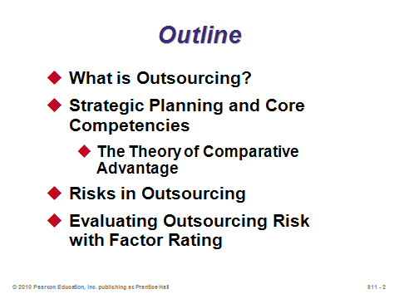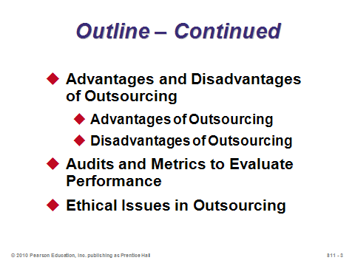

**S11-1 S11-2 S11-3**

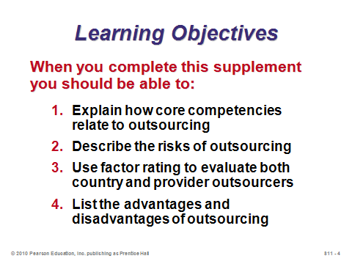

**S11-4**

WHAT IS OUTSOURCING? (S11-5 through S11-11)

Slides 6-11: These slides introduce the concept of outsourcing. We often immediately assume that outsourcing always implies that jobs are sent to other countries, but that is not always the case. Processes are often outsourced to domestic providers, as often happens when firms use 3rd-party logistics providers (see Chapter 11). Outsourcing extends the idea of subcontracting by replacing, as opposed to just augmenting, entire processes. The media often uses the term outsourcing to refer to *offshoring*; however, the two terms are not the same because the firm retains control when offshoring. Slide 8 provides three reasons why the practice of outsourcing is increasing. As firms become more specialized and focus on their core competencies, they realize that other companies may be able to perform certain functions more efficiently and effectively for them. Slide 9 provides several outsourcing examples, while Slide 10 identifies common processes that are outsourced. Slide 11 (Table S11.1) provides a ranking of desirable outsourcing destinations out of 50 countries in the annual A.T. Kearney Global Options survey. Scores incorporate financial attractiveness, workforce availability, employee skill set, and business environment. A.T. Kearney publishes quite a bit of information in this area, and the details change between reports. More detailed information from 2009 is provided in Other Supplementary Material below.

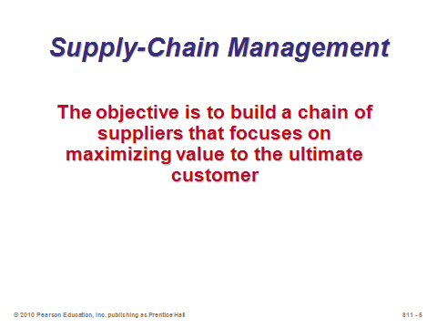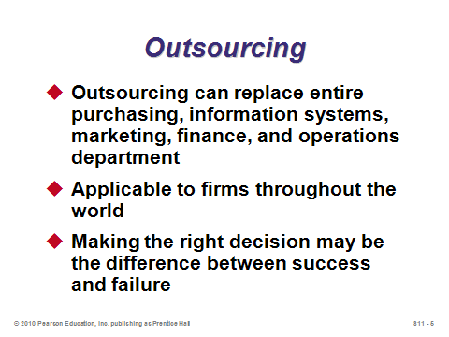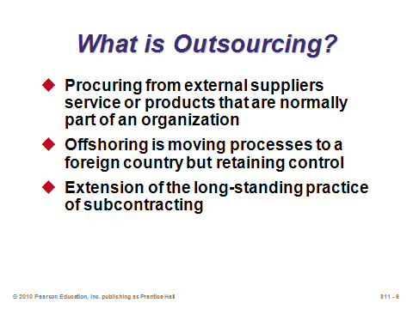

**S11-5 S11-6 S11-7**

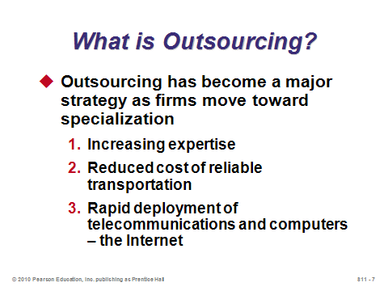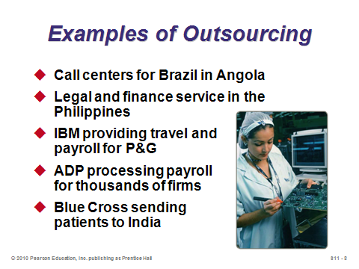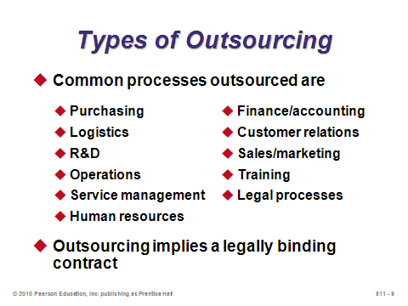

**S11-8 S11-9 S11-10**

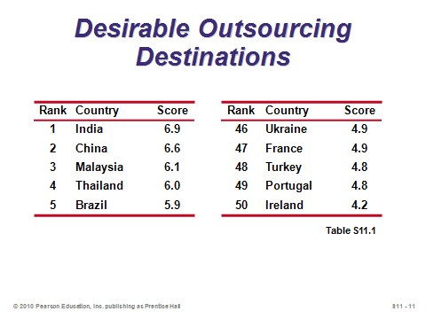

**S11-11**

STRATEGIC PLANNING AND CORE COMPETENCIES (S11-12 through S11-18)

Slide 12: This slide relates back to Chapter 2 and the discussion of corporate strategies. The idea of specialization is to figure out what the firm does best, its *core competencies*, and to focus on those—leaving other processes as potential candidates for outsourcing.

Slide 13: This slide (Figure S11.1) suggests that Sony definitely needs to focus on its core competency of being the world’s best at electromechanical miniaturization design, but all of the processes on the exterior of the circle are candidates for potential outsourcing. Should Sony try to become an expert in all of those functions, or should it pay other firms that are already experts in those areas to perform the functions for them?

Slide 14: The theory of comparative advantage states simply that firms should outsource processes that can be performed more productively by other companies. However, the theory ignores the many potential risks inherent in delegating any task, particularly to non-affiliated companies. Several such risks and disadvantages are detailed in later slides.

Slides 15-17: These slides present extra data not found in the text based on a survey of 53 major corporations. Slide 15 suggests that while cost savings is most important, it is hardly the only reason that companies outsource. The outsourcing provider often brings knowledge or technology that the outsourcing seeker lacks. Slides 16 and 17 imply that many outsourcing arrangements fail; thus, they need to be chosen and managed carefully.

Slide 18: The second primary bullet on this slide may surprise students because U.S. media outlets tend to focus on only one side of the outsourcing equation (the exporting of U.S. jobs).

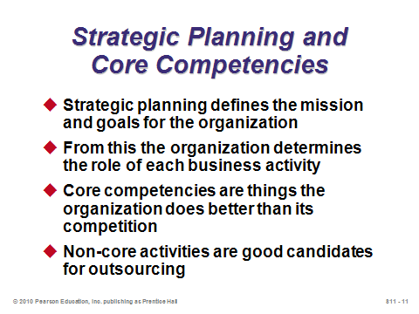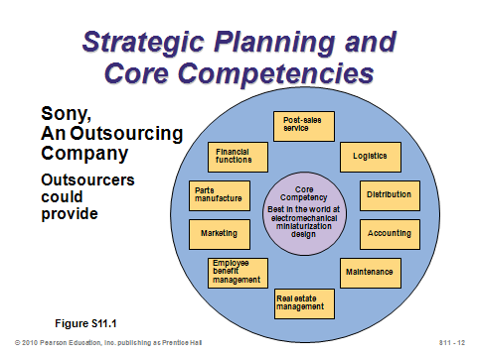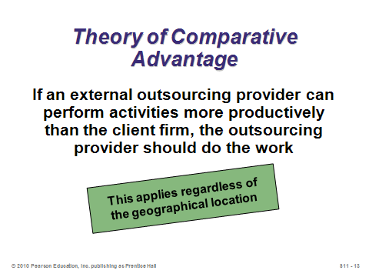

**S11-12 S11-13 S11-14**

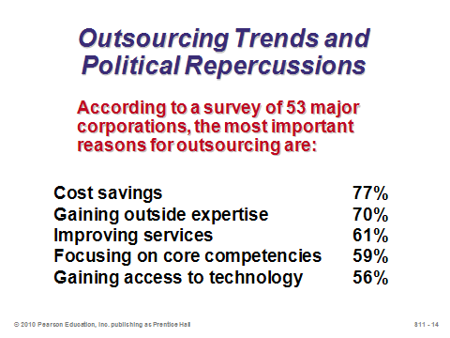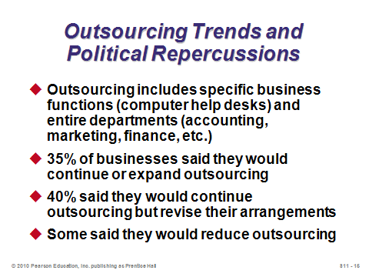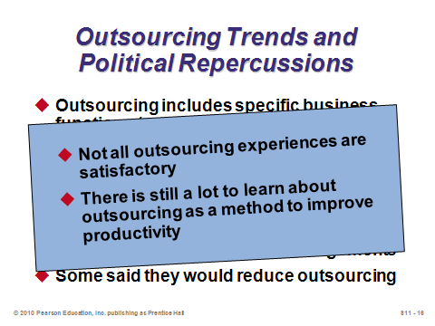

**S11-15 S11-16 S11-17**

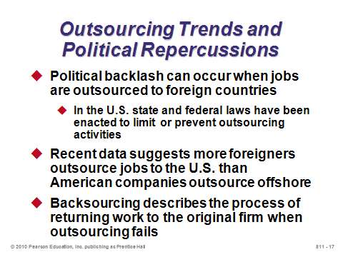

**S11-18**

RISKS OF OUTSOURCING (S11-19 through S11-24)

Slide 19: An outsourcing failure can be detrimental to the company and can severely damage its reputation. Here we see that failures are quite common and can be caused by many different reasons that are primarily outside of the firm’s direct control. Other times managers simply set the goals of outsourcing too high, making modest gains appear to be failures.

Slides 20-23: From Table S11.2, significant risks appear in every step of the outsourcing process. Sufficient understanding and analysis at every stage is the key to success.

Slide 24: This slide identifies three other outsourcing issues. The first bullet suggests that a change of employment levels may imply layoffs, which is expensive, causes harm to current loyal employees, and may damage the morale of those who remain. The second bullet refers to the disruption to current systems when any major process is significantly altered (there may be many hidden integration and change costs in this case). The third bullet includes issues such as insurance, customs, and timing.

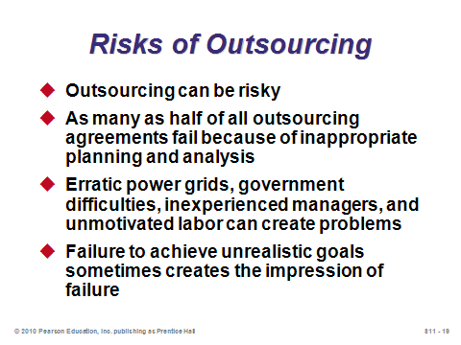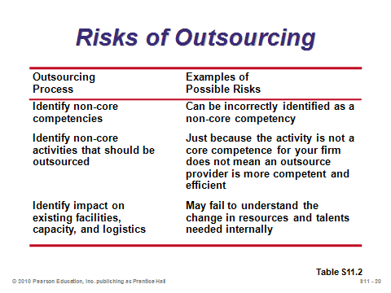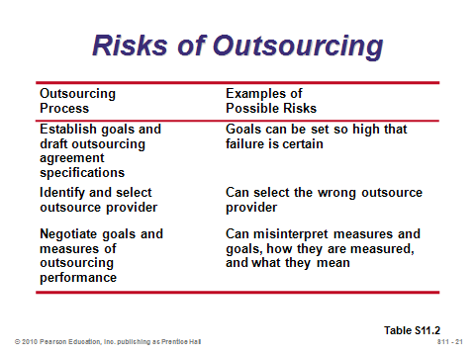

**S11-19 S11-20 S11-21**

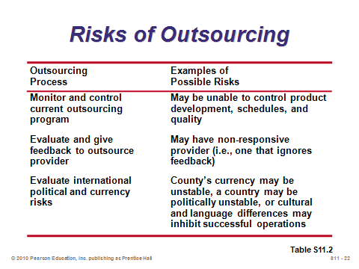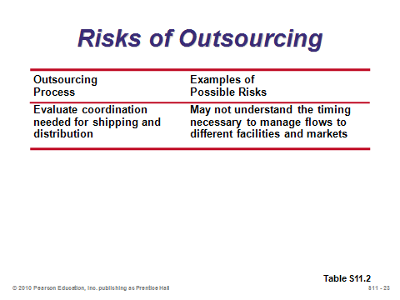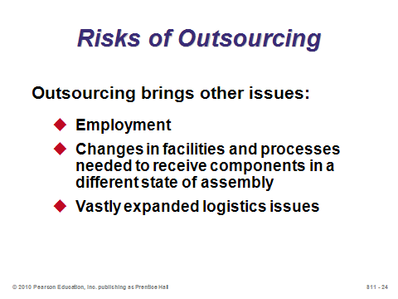

**S11-22 S11-23 S11-24**

EVALUATING OUTSOURCING RISK WITH FACTOR RATING (S11-25 through S11-27)

Slides 25-27: The factor-rating method introduced in Chapter 8 can be applied to country risk assessment (Slide 26 based on Example S1) and provider selection (Slide 27 based on Example 2). In the first example, the risk factors are assigned equal weight, so the scores can simply be summed. In Example 2, different factors are assigned difference importance weights, so a weighted average must be computed. In other real applications, managers can add factors and assign different weights as they deem fit. To keep things simple, all factors should move in the same direction, that is, either low scores are good for all factors (as in Example 1) or high scores are good for all factors (as in Example 2).

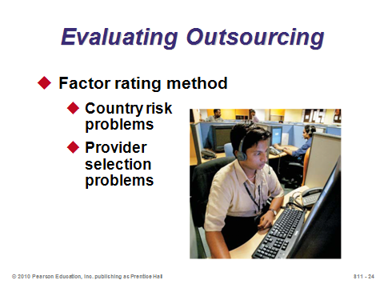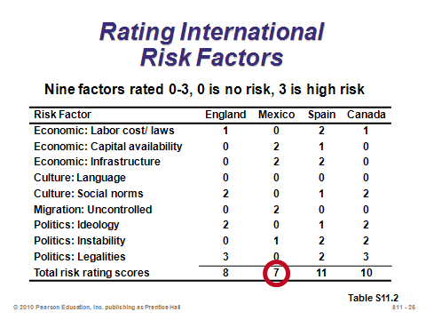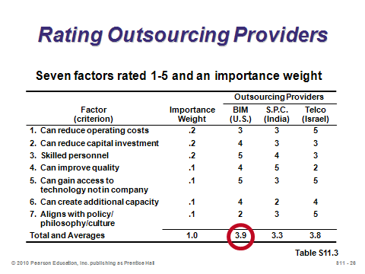

**S11-25 S11-26 S11-27**

ADVANTAGES AND DISADVANTAGES OF OUTSOURCING (S11-28 through S11-29)

Slide 28: The outsourcing advantages identified here correspond quite nicely to the corporate survey results in Slide 15.

Slide 29: This slide identifies major outsourcing disadvantages. The final bullet refers to the phenomenon that many of the risks firms run by outsourcing may not show up in profit statements until sometime in the future, encouraging short-run thinking fast-track managers to produce short-run profit increases that they can attribute to their outsourcing decisions.

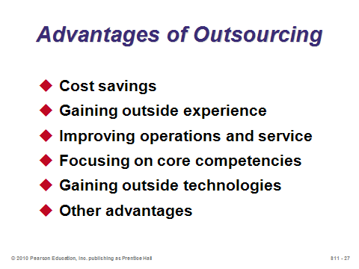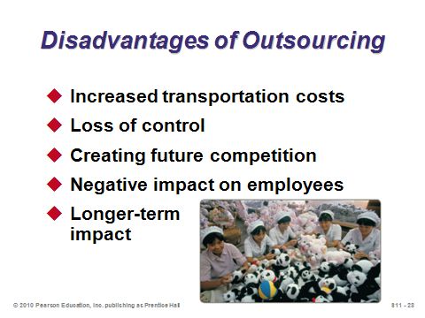

**S11-28 S11-29**

AUDITS AND METRICS TO EVALUATE PERFORMANCE (S11-30)

Slide 30: This slide applies to any important contractual relationship between companies, including most outsourcing relationships. Certain metrics may need to be reported daily.

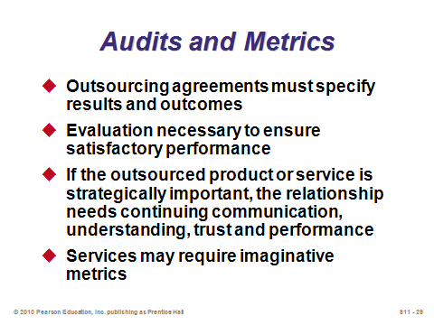

**S11-30**

ETHICAL ISSUES IN OUTSOURCING (S11-31 through S11-32)

Slides 31-32: These slides reproduce Table S11.5, which presents several tenets of conduct that have fairly universal acceptance. Good class discussion can blossom from these slides, particularly if instructors provide related scenarios or real examples of potential ethics violations. If any students are *Star Trek* fans, instructors can ask them to describe to the rest of the class Star Fleet’s *Prime Directive* (there can be no interference with the internal development of pre-warp civilizations). *Real Star* *Trek* fans can describe episodes where either the prime directive hindered the crew’s goals or where the captain violated the prime directive and why that action was justified in the captain’s mind.

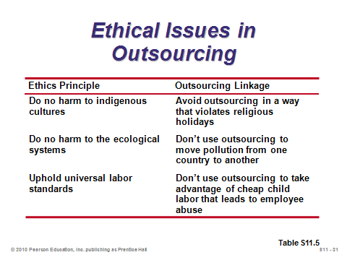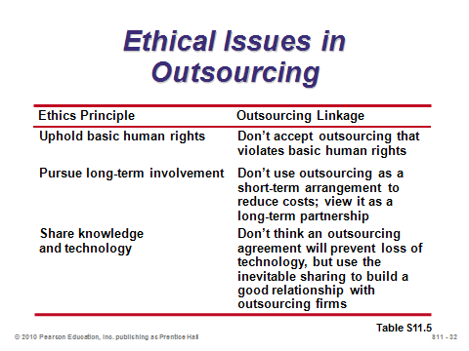

**S11-31 S11-32**

**Additional Assignment Ideas**

1. A number of opportunities and trends regarding outsourcing can be found at The Outsourcing Institute (www.outsourcing.com). Report on two outsourcing or offshoring opportunities/trends.
2. Look up the World Trade Organization Web sites. Report on what is the WTO.

**Additional Case Study**

Richard Ivey School of Business (http://cases.ivey.uwo.ca/cases/pages/home.aspx)

* *UPS and HP: Value Creation Through Supply Chain Partnerships* (#9B07D002): This case is about managing large supply change outsourcing relationships over time. The focus is on the challenges service providers and their customers face as they seek to continually find new sources of value as the relationships change.

**Internet Resources**

|  |  |
| --- | --- |
| Center for Global Outsourcing | www.outsourceglobal.org |
| Council of Foreign Affairs | www.foreignaffairs.org |
| Institute for Supply Management | www.ism.ws |
| Outsourcing Directory | www.offshorexperts.com |
| Outsourcing Global Services Directory | www.outsourcing.org |
| The Outsourcing Institute | www.outsourcing.com |
| World Trade Organization | www.wto.org |

**Other Supplementary Material**

Videos

Films available from:

Humanities and Sciences

(P) 800-257-5126

(F) 609-275-1400

(E) custserv@films.com

http://www.films.com

* *Outsourcing: White Collar Exodus* (Item# BVL34962)
* *Toyota’s Drive to the Top* (Item#:BVL37611)
* *Product Design: A Hand-Made Stereo for a Hand-Made Car* (Item#:BVL33025)

Country Comparison Data from A.T. Kearney

